Waycross and Ware County Development Authority
(Version 4 04.17.2025)

Request for Proposals

The Waycross and Ware County Development Authority is accepting proposals from qualified contractors for land clearing for a cumulative total of approximately 122.02+/- acres on three distinct parcels. The project will include the removal of trees, stumps, rubbish, and other vegetation that may be located on the site. Proposals are due by 10:00 AM (Eastern) on Wednesday, April 30, 2025.

The following options for submission of Proposal Packages are acceptable:
- Emailed to Jason@wwda.us – the “subject line” of the email should read “WWDA RFP – Land Clearing”
- Hand delivery, U.S. Mail or other express delivery service to:
Waycross and Ware County Development Authority
2855 Forest Drive
Waycross, GA 31503

For information regarding proposals, contact Jason Rubenbauer at (912) 283-2112 or Jason@wwda.us.

The Waycross and Ware County Development Authority reserves the right to accept or reject, any or all proposals, and to award the contract in phases or to multiple parties.

***SEE ATTACHED TECHNICAL SPECIFICATIONS, TERMS, AND CONDITIONS, NON-COLLUSION AFFIDAVIT, CONTRACTOR AFFIDAVIT AND AGREEMENT, SUBCONTRACTOR AFFIDAVIT AND AGREEMENT (if applicable), AND CONTRACTOR’S DECLARATION***

Technical Specifications

Description. This item shall consist of the clearing of the three parcels identified below of all trees, brush, overhangs, logs, stumps, trash, rubbish, and other debris, including any deleterious materials within the limits of the project. For the purposes of this specification, the boundaries of the parcels shall be defined by the Ware County Tax Assessor’s Office. Upon completion of the land clearing, Contractor shall be responsible for reseeding grass for beautification and erosion control.
It shall be the responsibility of the Contractor to visit the project site(s) and ascertain the clearing requirements as included in the proposal documents before submitting a proposal on the project. Any necessary trimming of overhangs that encroach the right-of-way and interfere with the facilitation of construction or the operation of maintenance of the executed project will not be paid for separately.

Construction methods. The property shall be cleared of all trees, brush, overhangs, logs, rubbish, shrubs, and other trash. Items and certain areas designated by the Owner for preservation in accordance with determination by the US Army Corps of Engineers designated as jurisdictional wetlands shall be carefully protected from abuse, marring, or damage during construction operations and preserved in accordance with the Proposal Documents. Parking and/or servicing of equipment in protected areas is strictly prohibited.

Disposal of materials. All cleared vegetative materials shall be disposed of by piling and burning in accordance with the Contractor working with local fire officials to ensure that impacts on public safety and the environmental effects for surrounding industries are minimized. All approved burning activities shall be conducted using means to minimize low level smoke accumulation which may impact the safety of motorists or cause a nuisance for existing industries located near the project site(s). The Contractor shall dispose of tires, rubbish, and other debris in an approved facility. The Contractor shall be responsible for obtaining any necessary disposal permits. The cost of such disposal shall be included in the pricing proposed. The contractor shall not bury any refuse on any property owned by the Waycross and Ware County Development Authority.

Limit of operations. No clearing shall be completed outside of the parcel boundaries. Any work completed outside of the parcel boundaries shall be done at the Contractor’s expense and it shall be the Contractor’s responsibility to negotiate and secure the permission of the property owner for such operation. The Contractor shall provide sufficient evidence to the Waycross and Ware County Development Authority that such permission has been obtained.

Schedule of Clearing. The timeframe for completion of all clearing activities for the total of the three parcels is 120 days from the issuing of the Notice to Proceed.

Measurement and Payment. Clearing will be paid at the contract price per parcel, as designated in the proposal and shall be full compensation for furnishing all labor, materials, permits, supervision, equipment, and supplies required to complete all items of work specified herein.

Land Clearing Specifications
Part I – General
- Work Included
  - Contractor shall clear vegetative materials (i.e. trees, shrubs, stumps, etc.) via cutting, mulching, root raking, and/or mowing on each of the identified parcels. Trees, logs, shrubs, stumps, and other vegetations shall be piled and burned on each respective parcel away from public rights-of way and existing industries.

  - Contractor shall be responsible for utility location/identification (Call 811), site safety, owner/neighbor access, traffic control, and protection of existing facilities, features, and structures at all times.

  - Contractor shall install appropriate silt fencing or other required containment around the boundaries to minimize the negative effects of stormwater runoff and debris intrusion onto neighboring properties including any and all waterways.

  - Contractor shall provide permanent site grassing and proper fertilization to establish erosion controls while enhancing the beautification of the site following the end of the construction period.

  - Contractor shall follow all Best Management Practices as provided by the Georgia Environmental Protection Division and other regulating bodies as required for all construction and land clearing projects of this nature.

  - Contractor shall ensure all stumps, roots, large clumps of dirt or other obstructions are removed from the sit to allow the owner to properly maintain the property by mowing with standard tractors and deck mowers.

  - Contractor shall apply 10-21-21 with 3% sulfur fertilizer at a spread rate of 413 lbs. per acre prior to seeding of grass. Grass seed shall be comprised of a mix of 10 lbs. Bermuda grass and 80 lbs. brown top millet evenly distributed per acre. Once the seed has established, contractor shall conduct a second application of fertilizer using the same methods and materials as the initial application.

- Quality Assurance
  - All work described in these specifications, and all work necessary to completely finish work as described, shall be performed in a professional manner.

  - All work shall be done by persons who are thoroughly experienced and trained in their particular trade or craft.

- Methods of Measurement/Basis of Payment
  - No explicit direct payment shall be made for incidental work under this section. Direct and indirect costs for this work shall be included in unit process provided on the Proposal Forms.

- Site Conditions
  - Protect existing buildings, landscaping, roads, fences, drives, curbs, utilities, jurisdictional wetlands, and other features from damage from work in this Section.

  - In the event of damage, the Contractor shall immediately affect all repairs and replacements necessary subject to the approval of the Property Owner at no cost to the Waycross and Ware County Development Authority.

- Regulatory Requirements
  - Obtain written permission from authority having jurisdiction before using storm sewers, ditches, or other existing drainage facilities for water disposal.

- Bonds and Insurance
  - Contractor shall furnish a performance bond and a payment bond, each in an amount at least equal to the Contract Price, as security for the faithful performance and payment of all Contractor’s obligations under the Contract. These bonds shall remain in effect until one year after the date when final payment becomes due or until completion of the correction period, whichever is later. Contractor shall obtain the required bonds from surety companies that are duly licensed or authorized in the jurisdiction in which the Project is located to issue bonds in the required amounts. If contractor fails to obtain a required bond, Owner may exclude the Contractor from the Site and exercise Owner’s termination rights.

  - A bid bond in the amount of 10% of the bid shall be provided by a licensed surety.

  - Contractor must provide proof of insurance, listing the Waycross and Ware County Development Authority as an Additional Insured. Minimum coverage shall include:
    - General Liability Insurance of: Aggregate $2,000,000/Occurrence $1,000,000 and:

    - Workers Compensation: $1,000,000 each accident

Part II – Products
(Section not used)

Part III – Execution
- Timeframe
  - The timeframe for completion of all clearing activities for the total of the three parcels is 120 days from the issuance of the Notice to Proceed.

- Protection
  - Utility Lines: Protect existing utility lines from damage. Notify the Inspector immediately of damage to or an encounter with an unknown existing utility line. Contractor is responsible for repairing damage to existing utility lines that are indicated or made known to the Contractor prior to the start of clearing operations.

- Clearing
  - Clearing shall consist of the felling, trimming, and cutting of trees, the removal of all stumps, and the satisfactory burning and/or disposal of the trees, stumps, and other vegetation designated for removal, including downed timber, snags, brush, and rubbish occurring in the areas to be cleared.

- Tree Removal
  - Where indicated or directed, trees and stumps that are designated as trees shall be piled and burned or properly disposed of off-site, unless trees have marketable value. Trees, shrubs, stumps, and other vegetation with no marketable value are to be piled and burned or removed from the parcel and properly disposed of as specified in paragraph “Disposal of Materials”. All permits are the responsibility of the contractor.

- Waycross Fire Prevention and Protection Ordinance (Ch. 18-1(a)(8))
  - Open burning of vegetative material for the purpose of land clearing using an air curtain destructor, provided the following conditions are met:
    - The location of the air curtain destructor is at least 300 feet from any occupied structure or public road or private road. An air curtain destructor used solely for utility line clearing or road clearing may be used at a lesser distance upon approval of the department of natural resources, or environmental protection division;

    - No more than one air curtain destructor is operated within a ten-acre area at one time or there must be at least 1,000 feet between any two air curtain destructors;

    - Only wood waste consisting of trees, logs, large brush and stumps which are relatively free of soil are burned in the air curtain destructor;

    - Tires or other rubber products, plastics, heavy oils or asphaltic based or impregnated materials are not used to start or maintain the operation of the air curtain destructor;

    - The air curtain destructor is constructed, installed and operated in a manner consistent with good air pollution control practice for minimizing emissions of fly ash and smoke;

    - The cleaning out of the air curtain destructor pit is performed in a manner to prevent fugitive dust; and

    - The air curtain destructor cannot be fired before 10:00 am and the fire must be completely extinguished, using water or by covering with dirt, at least one hour before sunset.

  - Permit required. Except as otherwise provided by law, a permit must be obtained from the city fire department prior to kindling a fire for recognized silviculture or range or wildlife management practices, prevention or control of disease or pests or a bonfire. Application for such permits shall only be made by the owner of the land upon which the fire is to be kindled or the duly authorized representative of such owner.

  - Revocation of permit. The city fire chief or his designee may revoke a permit issued pursuant to subsection (b) of this section, when the fire chief or his designee finds by inspection or otherwise that:
    - The permit is sued for a location or establishment other than that for which the permit was issued;

    - The permit is used for a condition or activity other than that authorized in the permit;

    - The conditions and limitations set forth in the permit have been violated;

    - There have been any false statements or misrepresentations as to a material fact in the application or permit or plans submitted therewith or a condition of the permit;

    - If neighbors complain about the smoke.

  - Attendance. Open burning, bonfires or recreational fires shall be constantly attended by the permittee or other person designated in the permit until the fire is completely extinguished. A minimum of one portable fire extinguisher with a minimum of 4-A rating or other approved on-site fire extinguishing equipment, such as dirt, sand, water barrel, garden hose or water truck, shall be kept at the fire location and available for immediate utilization to extinguish the fire.

- Disposal of Materials
  - Salable Timber: The Contractor shall have the ability to market and sell the timber, trees, and stumps on any or all three parcels of land. The monetary amount received for any timber, trees, or stumps designated for sale by the Contractor shall be calculated in the Contractor’s overall price.

  - Nonsalable materials: Logs, stumps, roots, brush, rotten wood, and other refuse from the clearing operations shall be piled and burned as prescribed by local fire authorities.

  - Trash, rubbish, tires, and other material considered refuse shall be disposed of in an appropriate facility. Under no circumstances should this material be buried or disposed of on-site. The cost of this disposal shall be included in the pricing proposed.

- Environmental Conditions
  - A buffer of 25 horizontal feet shall be maintained from the banks of any stream or otherwise identified waters of the state. This buffer shall be measured horizontally from the point where the vegetation has been wrested by normal stream flow. Adequate erosion control measures must be deployed in sensitive areas.

  - At no time shall land clearing activities be conducted in an area considered to be a wetland.

  - The Contractor shall be responsible for adhering to the requirements listed above and avoid activities in an environmentally sensitive area.

- Health and Safety
  - Contractor is responsible for determining health and safety requirements sufficient to provide for employee and public protection.

  - Contractor shall comply with all federal, State of Georgia, and County of Ware regulations.

  - Waycross and Ware County Development Authority assumes no responsibility for theft, vandalism, or destruction of any property belonging to the Contractors, their Subcontractors, or Suppliers. Contractor is responsible for securing all equipment when not in use and always assumes full responsibility.

- Documentation
  - Contractor shall keep a continuous record of the following:
    - Date and time of beginning and completion of work each day
    - Equipment onsite

    - Work completed and material used.

    - Location of Work.

    - Any other applicable information.

Proposal Form: Parcel One
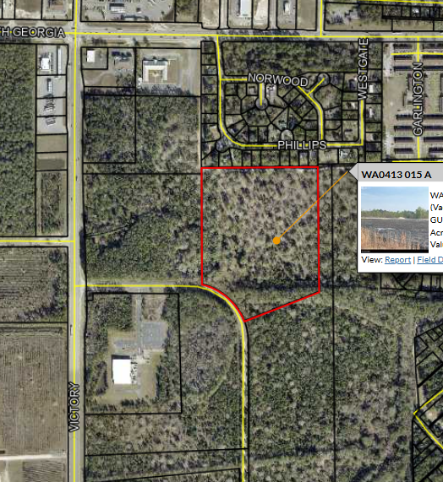
Parcel Number: WA0413 015 A
Physical Location:
Total Acres: 20.00
Stumping, & Grubbing Price: $

Grassing & Fertilization Price $

Total Price for Parcel One: $

Proposal Form: Parcel Two
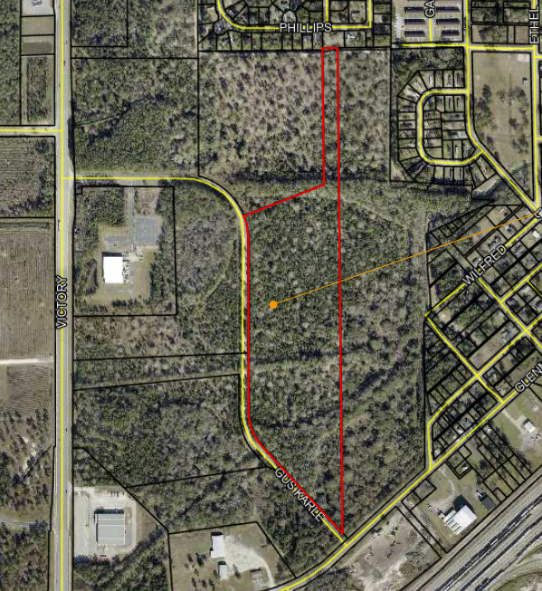
Parcel Number: WA0413 013
Physical Location:
Total Acres to be cleared: 31.10
Stumping, & Grubbing Price: $

Grassing & Fertilization Price $

Total Price for Parcel Two: $

Proposal Form: Parcel Three
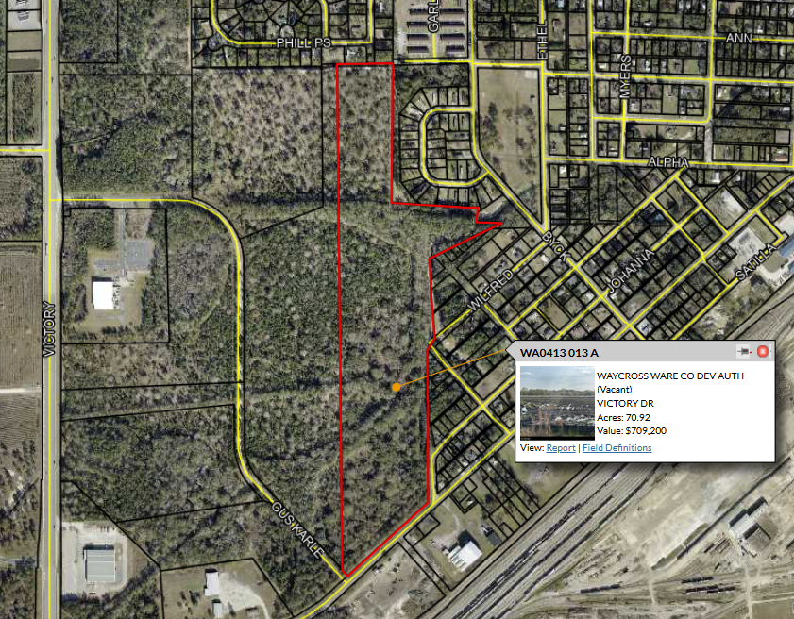
Parcel Number: WA0413 013 A
Physical Location:
Total Acres to be cleared: 70.92
Stumping, & Grubbing Price: $

Grassing & Fertilization Price $

Total Price for Parcel Three: $
Terms and Conditions
Applicable to Request for Proposals
WAYCROSS AND WARE COUNTY DEVELOPMENT AUTHORITY
TERMS AND CONDITIONS APPLICABLE TO REQUEST FOR PROPOSALS
RE: LAND CLEARING OF PARCELS

Date: April 4, 2025

The WWDA reserves the right to accept or reject all proposals, to waive informalities in the response or RFP process, and to negotiate with or select any respondent or other party, without proceeding further with the RFP process, in the discretion of the WWDA. Qualifications of the selected respondent rest heavily on the expertise of the respondent; the WWDA is not bound to select the “lowest offer” and may award the project in multiple phases or to multiple parties.

These terms and conditions apply to the RFP:
- All proposals and supporting materials, as well as correspondence relating to the RFP, become property of the WWDA when received. All expenses for preparing and submitting proposals are the sole cost of the party submitting the proposal. The WWDA is not obligated to any party to reimburse such expenses. Labeling information provided in submittals “proprietary” or “confidential” or any other designation of restricted use will not protect the information from public view. Submittals are subject to the provisions of the Georgia Open Records Act.

- All applicable Federal and State of Georgia laws, Ware County ordinances, and license requirements and regulations of all agencies having jurisdiction shall apply to the respondents throughout and are incorporated herein.

- Professionals requiring special licenses must be licensed in the State of Georgia and shall be responsible for those portions of the work as may be required by law.

- No proposal shall be accepted from, and no contract will be awarded to, any respondent that (i) is in arrears to Ware County or the City of Waycross with respect to any debt. Or (ii) is in default with respect to any obligation to the WWDA.

- Pursuant to O.C.G.A. § 13-10-91, qualifying contractors and subcontractors performing work within the State of Georgia on a contract with the WWDA must register and participate in a federal work authorization program. A certification form verifying participation in such a program will be required of all respondents in addition to the S.A.V.E. Program Affidavit by the WWDA in compliance with O.C.G.A § 50-36-1.

- In conjunction with the execution of the agreement, the selected respondent shall provide evidence of worker’s compensation, general liability and professional malpractice insurance to the WWDA to cover the acts and omissions of the respondent’s principals, employees and agents, and any sub-contractors in rendering services within the scope of and in compliance with the agreement. Said insurance must be satisfactory to the WWDA. The cost of such insurance shall be included in the respondents’ proposal.

The agreement will contain additional terms and conditions.

Waycross and Ware County Development Authority
2855 Forest Drive, Waycross, GA 31503

NON-COLLUSION AFFIDAVIT
The following affidavit it to accompany any proposal:

STATE OF

COUNTY OF

Owner, Partner or Officer of Firm

Company Name, Address, City, and State

being of lawful age, being first duly sworn, on oath says that he/she is the agent authorized by the contractor to submit the attached proposal. The Affiant further states as contractor, that they have not been a party to any collusion among contractors in restraint of competition by agreement to proposal at a fixed price or to refrain from submitting proposal. Affiant also states as contractor, that they have not been a party to any collusion with and officer of the Waycross and Ware County Development Authority or any of their employees as to quantity, quality, or price in the prospective contract; and that discussions have not taken place between contractors and any office of the Waycross and Ware County Development Authority or any of their employees concerning exchange of money or other things of value for special consideration in submitting a proposal for:

FIRM NAME

Signature

Title

Subscribed and sworn to before me this day of , 20 .

Notary Public

WAYCROSS AND WARE COUNTY DEVELOPMENT AUTHORITY

CONTRACTOR AFFIDAVIT AND AGREEMENT

By executing this affidavit, the undersigned contractor verifies its compliance with O.C.G.A. § 13-10-91, stating affirmatively that the individual, firm, or corporation which is contracting with the Waycross and Ware County Development Authority has registered with and is participating in a Federal Work Authorization Program* [any of the electronic verification of work authorization programs operated by the United States Department of Homeland Security to verify information of newly hired employees, pursuant to the Immigration Reform and Control Act of 1986 (IRCA) P.L. 99-603], in accordance with the applicability provisions and deadlines established in O.C.G.A. § 13-10-91.

The undersigned further agrees that, should it employ or contract with any subcontractor(s) in connection with the physical performance of services pursuant to this contract the Waycross and Ware County Development Authority, the contractor will secure from such contractor(s) similar verification of compliance with O.C.G.A. § 13-10-91 on the Subcontractor Affidavit provided in Rule 300-10-01.08 or a substantially similar form. Contractor further agrees to maintain records of such compliance and provide a copy of each such verification to the Waycross and Ware County Development Authority at the time the subcontractor(s) is retained to provide the service.

EEV/Basic Pilot Program* User Identification Number

BY: Authorized Officer or Agent Date

Title of Authorized Office or Agent

SUBSCRIBED AND SWORN BEFORE ME ON THIS DAY OF , 20

Notary Public

My Commission Expires:

*As of the effective date of O.C.G.A. § 13-10-91, the applicable federal work authorization program is the “EEV/Basic Rule Pilot Program” operated by the U.S. Citizenship and Immigration Services Bureau of the U.S. Department of Homeland Security, in conjunction with the Social Security Administration (SSA).

WAYCROSS AND WARE COUNTY DEVELOPMENT AUTHORITY

SUBCONTRACTOR AFFIDAVIT AND AGREEMENT

By executing this affidavit, the undersigned subcontractor verifies its compliance with O.C.G.A. § 13-10-91, stating affirmatively that the individual, firm, or corporation which is contracting with the Waycross and Ware County Development Authority has registered with and is participating in a Federal Work Authorization Program* [any of the electronic verification of work authorization programs operated by the United States Department of Homeland Security to verify information of newly hired employees, pursuant to the Immigration Reform and Control Act of 1986 (IRCA) P.L. 99-603], in accordance with the applicability provisions and deadlines established in O.C.G.A. § 13-10-91.

EEV/Basic Pilot Program* User Identification Number

BY: Authorized Officer or Agent Date
(Subcontractor Name)

Title of Authorized Office or Agent of Subcontractor

SUBSCRIBED AND SWORN BEFORE ME ON THIS DAY OF , 20

Notary Public

My Commission Expires:

*As of the effective date of O.C.G.A. § 13-10-91, the applicable federal work authorization program is the “EEV/Basic Rule Pilot Program” operated by the U.S. Citizenship and Immigration Services Bureau of the U.S. Department of Homeland Security, in conjunction with the Social Security Administration (SSA).

CONTRACTORS DECLARATION

The contractor understands, agrees and warrants:
- That the contractor has carefully read and fully understands the full scope of the specifications.

- That the contractor has the capacity to successfully undertake and complete the responsibilities and obligations in said specifications.

- That this proposal may be withdrawn by requesting such withdrawal in writing at any time prior to the scheduled proposal opening but may not be withdrawn after such date and time.

- That the Waycross and Ware County Development Authority reserves the right to reject any or all proposals and to accept that proposal which will, in its opinion, best serve the public interest. The Waycross and Ware County Development Authority reserved the right to award the proposal to separate contractors when more than one item appears on the schedule. The Waycross and Ware County Development Authority reserves the right to waive any technicalities and formalities in the proposal package.

- That the contractor understands that these specifications are the minimum requirements and must be met or exceeded to be considered by the Waycross and Ware County Development Authority. The contractor acknowledges that the item proposal is suitable for the intended application.

- That by submission of this proposal the contractor acknowledged that the Waycross and Ware County Development Authority has the right to make any inquiry or investigation it deems appropriate to substantiate or supplement information supplied by the contractor.

If a partnership, a general partner must sign.

If a corporation, the authorized corporate officer(s) must sign, and the corporate seal must be affixed to this proposal.

CONTRACTOR:

Name Title

Name Title

AFFIX CORPORATE SEAL (if applicable)

