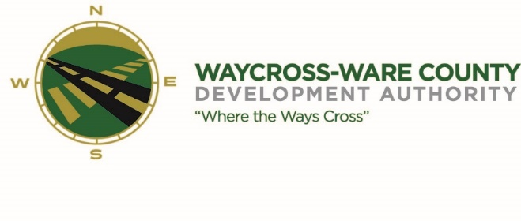
October 16, 2018
3:00 P.M
MEETING AGENDA
WWDA Board of Directors

- Call to Order
- Invocation
- Approval of Agenda
- Approval of September 18, 2018 Minutes
- Chairman’s Report:
- Report of Activities
- Executive Director’s Report:
- Report of Activities
- Finance Committee:
- Report of Finances
- SPLOST Balances:
  - 2008 Balance:
  - 2014 Balance:
- Pending Business:
- Chamber of Commerce/Business Community Report
- Downtown Waycross Development Authority Report
- Main Street Report
- Tourism
- New Business:
  - Survey Selection
  - Corporate Park Appraisal
  - Marketing (Video & Photos)
- Attorney’s Items:
- Executive Session:
- For discussion of land lease and acquisition pursuant to 50-14-3(b)(1)(B)
- For discussion of pending or potential litigation 50-14-2
- Adjournment

