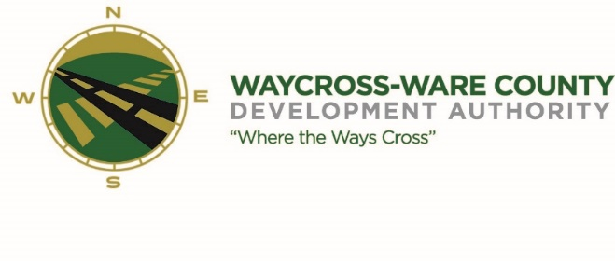
June 21, 2018
10:00 A.M.
MEETING AGENDA
WWDA Board of Directors

- Call to Order
- Invocation
- Approval of Agenda
- Approval of April 26, 2018 Minutes
- Chairman’s Report:
- Report of Activities
- Executive Director’s Report:
- Report of Activities
- Finance Committee:
- Report of Finances
- SPLOST Balances:
  - 2008 Balance:
  - 2014 Balance
  - Audit
    - 2017
- Pending Business:
- Chamber of Commerce/Business Community Report
- Downtown Waycross Development Authority Report
- Main Street Report
- Tourism
- Board of Directors E-mails
- Signs are in place
- Attorney
- Suncorp/ERC

- New Business:
- Industrial Meet and Greet
- Legislative Luncheon
- Greg Haynes with CBRE
- Executive Session:
- Adjournment

