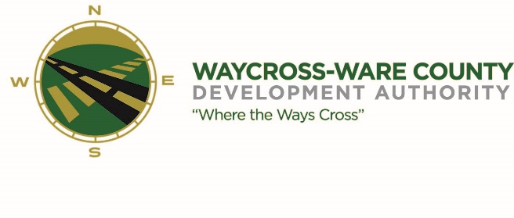
MEETING AGENDA
WWDA Board of Directors
September 14, 2023
10:00 A.M.
City Hall
Waycross, Ga 31503

Board Members Present: Staff Present:
Candice Moody-Rice Jason Rubenbauer
Daniel Morris Kalissa Corbitt
James Willis David Rafus Board Members Absent:
Dr. Michael Angelo James
Rusty Hall
Stephen Burse

Guest:
Hillary Stringfellow
Taylor Hereford
- Call to Order
The regular meeting of the Waycross and Ware County Development Authority was called to order by Chairman Daniel Morris at 10:02 AM.

- Approval of Agenda
James Willis made a motion to approve the agenda as presented. David Rafus seconded the motion. All members present voted aye. The motion was unanimously approved by a vote of 7-0.

- Approval of Minutes
- Michael Angelo James made a motion to approve the minutes as presented. Seconded by David Rafus. All members voted aye. The motion was unanimously approved by a vote of 7-0.

- Approval of Financials
- David Rafus made a motion to approve the financials as presented. Seconded by James Willis. All members voted aye. The motion was unanimously approved 7-0.

- Community Reports
- WWCOC- N/A
- DWDA- N/A
- WCVB- N/A
- CPTC- N/A
- SGSC- Taylor Hereford gave a brief update.
- WCBOE- N/A

- Old Business
  - Jason Rubenbauer gave an update on signage landscaping and the Victory Park signage.

- New Business
  - Dan Good made a motion to reject the bids for the land clearing bid and re-advertise based on a suggestion from Jason Rubenbauer, seconded by Stephen Burse. All voted aye, unanimously approved 7-0.
  - Dan Good made a motion to reject bids for the ROW ditch clean up, seconded by Candice Rice; all voted aye, unanimously approved 7-0.
  - Dr. Michael-Angelo James made a motion to approve the engineering survey costs to Georgia Power, seconded by Candice Rice; James Willis abstained from voting, all voted aye; 6-0.
  - Dan Good made a motion to move our October meeting date to October 12, 2023. Seconded by Stephen Burse, all voted aye, unanimously approved 7-0.
  - Candice Rice made a motion to approve the purchase of two tables for the Georgia Chamber Eggs and Issues event, seconded by Micheal Angelo James, all voted aye, unanimously approved 7-0.
- Attorney items
  - Hillary Stringfellow updated the board on current projects.

- Presidents Report

- Chairmans report

- Executive Session
- For discussion of land/lease and acquisition matters pursuant to 50-14-3(b)(1)(B)
- Michael Angelo James made a motion to enter executive session at 11:00 A.M.; seconded by Candice Rice, unanimously approved 7-0
- Adjournment
- The WWDA Closed executive session at 11:58 A.M after a motion from Michale Angelo James and seconded by David Rafus. Unanimously approved 7-0.
- The meeting was adjourned at 11:58 A.M.

