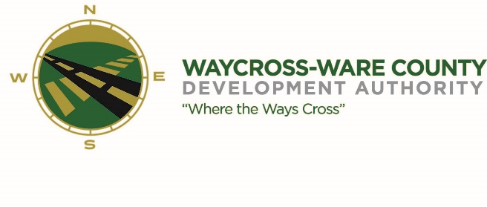
MEETING AGENDA
WWDA Board of Directors
July 20, 2023
10:00 A.M.
Telephonic/City Hall
Waycross, Ga 31503

Board Members Present: Staff Present:
Candice Moody-Rice Jason Rubenbauer
Daniel Morris Kalissa Corbitt
James Willis David Rafus Board Members Absent:
Dr. Michael Angelo James Stephen Burse
Dan Good
Rusty Hall

Guest:
Jon Whipple
Pete Snell
Hillary Stringfellow
- Call to Order
The regular meeting of the Waycross and Ware County Development Authority was called to order by Chairman Daniel Morris at 10:00 AM.
- Daniel Morris made a motion to move new business and attorney’s items to the top of the agenda. Seconded by James Willis. The motion was unanimously approved by a vote of 5-0

- Approval of Agenda
James Willis made a motion to approve the agenda as presented. David Rafus seconded the motion. All members present voted aye. The motion was unanimously approved by a vote of 5-0.

- New Business
- David Rafus made a motion to approve the REBA Resolution and to approve the officers to execute any documents. Seconded by James Willis. All members present voted aye. The motion was unanimously approved by a vote of 5-0.
- David Rafus made a motion to award the contract of cleaning and grubbing to Thrift Brothers. Seconded by James Willis. All members voted aye. The motion was unanimously approved by a vote of 5-0.
- James Willis made a motion to approve the hole sponsorship for the Chamber of Commerce Golf tournament. Seconded by David Rafus. All members voted aye. The motion was unanimously approved 5-0.

- Attorney items

- Approval of Minutes
- James Willis made a motion to approve the minutes as presented. Seconded by David Rafus. All members voted aye. The motion was unanimously approved by a vote of 5-0.

- Approval of Financials
- David Rafus made a motion to approve the financials as presented. Seconded by James Willis. All members voted aye. The motion was unanimously approved 5-0.

- Adjournment
No additional business was conducted, and the meeting was formally adjourned at 10:34 AM

