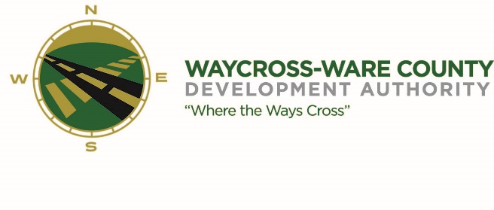
MEETING AGENDA
WWDA Board of Directors
June 22, 2023
10:00 A.M.
2855 forest Dr
Waycross, Ga 31503

Board Members Present: Staff Present:
Candice Moody-Rice Jason Rubenbauer
Dan Good Kalissa Corbitt
Daniel Morris James Willis Board Members Absent:
David Rafus Dr. Michael Angelo James
Stephen Burse Rusty Hall Guest:
Leonard Burse
Hillary Stringfellow
- Call to Order
The regular meeting of the Waycross and Ware County Development Authority was called to order by Chairman Daniel Morris at 10:04 AM.

- Invocation/Pledge of Allegiance
James Willis provided the invocation and Daniel Morris led the Pledge of Allegiance.

- Approval of Agenda
Dan Good made a motion to approve the agenda as presented. Candice Rice seconded the motion. All members present voted aye. The motion was unanimously approved by a vote of 7-0.

- Approval of Minutes
James Willis made a motion to approve the minutes of the May 18, 2023, meeting as presented. Dan Good seconded the motion. All members present voted aye. The motion was unanimously approved by a vote of 7-0.

- Approval of Financials
- Financials were not presented at this meeting and will be presented at the July meeting.

- Community Reports
- Waycross-Ware County Chamber of Commerce
There were no representatives present, and no report was provided.

- Downtown Waycross Development Authority
There were no representatives present, and no report was provided.

- Waycross Convention & Visitors Bureau
There were no representatives present, and no report was provided.

- Coastal Pines Technical College
There were no representatives present, and no report was provided.

- South Ga. State College
There were no representatives present, and no report was provided.

- Ware County Board of Education
There were no representatives present, and no report was provided.

- Old Business
- Website discussion and request for action
After discussion Candice Moody Rice made a motion to upgrade to the $10,500.00 package since we received a grant to cover the initial costs. The upgraded package will include photography and videography. Seconded by James Willis; unanimously approved 7-0.

- New Business
- Discussion and request for action on an Intergovernmental Agreement between Georgia’s Rural Center and the Waycross and Ware County Development Authority.
  - A motion was made by Rusty Hall to authorize Jason Rubenbauer to sign the agreement with Georgia’s Rural Center, seconded by David Rafus, all members present voted aye. The motion was unanimously approved by a vote of 7-0.
- Discussion and request for action pertaining to an advertising and promotion opportunity.
  - James Willis made a motion to reject the proposal and entertain it for next year, seconded by Candice Moody Rice. A unanimous vote of 7-0.
- Discussion and request for action to seek proposals to clean-up and repair the property located at 2821 Industrial Blvd;
  - Candice Rice made a motion to authorize Jason to receive bids, seconded by David Rafus. All members present voted aye. Unanimously approved 7-0.
- Discussion and request for action to seek proposals to clean the drainage ditch along the railroad track accessing GATX property.
  - During conversation, WWDA Attorney Hillary Stringfellow noted that the title work to this track needed to be cleaned up. Dan Good made a motion to move forward with cleaning up title work, seconded by Candice Rice. All members present voted aye. Unanimously approved 7-0.
  - Dan Good made a motion to also clean up the property as well. Seconded by Candice Rice, all members present voted aye. Unanimously approved 7-0.
- Discussion and request for action to seek proposals to conduct a comprehensive drainage study due to the negative impacts of the industrial park during recent rain events causing flooding concern for numerous existing businesses and industries.
  - Candice Rice made a motion to authorize Jason to seek proposals on a drainage study for the Airport Industrial Park. Seconded by Dan Good. All members present voted aye. Unanimously approved 7-0.
- Discussion and request for action to seek proposals for establishing and maintaining ground coverings at each of the new industrial park signs;
  - David Rafus made the motion to authorize Jason to seek proposals on establishing and maintaining ground coverings for the new signage. Seconded by Dan Good, All members present voted aye. Unanimously approved 7-0.

- Attorney’s Items
- Hillary Stringfellow – Gilbert, Harrell, Sumerford & Martin, P.C.
  - David Rafus made a motion to pay for the title work of the CF Rail property from SPLOST in the amount of $50,000.00 and to recoup the funds from future sales/leases, seconded Dan Good. Unanimously approved 7-0.
  - James Willis made a motion to authorize Daniel Morris to sign the agreement to add the 6 acres to their bond for title agreement for GATX Rail. Seconded by Dan Good. All members voted aye. Unanimously approved by 7-0.

- President’s Report – Jason Rubenbauer
- Jason went over his activities for the last month and gave updates on the local impact from the Conservation fund: Balancing Nature & Commerce Workshop and the Rural Development Institute.
- Chairman’s Report – Daniel Morris
- No report given.
- Executive Session
- For discussion of land/lease and acquisition matters pursuant to 50-14-3(b)(1)(B)
  - All members present voted aye. The Board entered Executive Session following a unanimous vote at 11:03 AM.
James Willis made a motion to exit the Executive Session and re-enter Regular Session. Dan Good seconded the motion. All members voted aye. All members present voted aye. Regular session reconvened at 11:25 AM following a unanimous vote of 7-0.

- Adjournment
No additional business was conducted, and the meeting was formally adjourned at 11:25 AM

