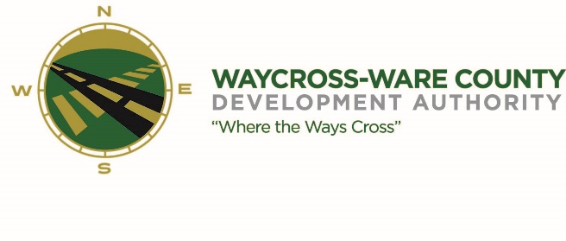
MEETING AGENDA
WWDA Board of Directors
May 11, 2023
10:00 A.M.
City Hall, Commissioners Chambers
Waycross, Ga 31503

Board Members Present: Staff Present:
Candice Moody-Rice Jason Rubenbauer
Dan Good Kalissa Corbitt
Daniel Morris James Willis Board Members Absent:
David Rafus Dr. Michael Angelo James
Rusty Hall

- Call to Order
The regular meeting of the Waycross and Ware County Development Authority was called to order by Chairman Daniel Morris at 10:01 AM.

- Invocation/Pledge of Allegiance
Chairman Daniel Morris provided the invocation and led the Pledge of Allegiance.

- Approval of Agenda
Candice Rice made a motion to approve the agenda as presented. David Rafus seconded the motion. All members present voted aye. Motion was unanimously approved by a vote of 5-0.

- Approval of Minutes
James Willis made a motion to approve the minutes of the April 20, 2023, meeting as presented. Candice Rice seconded the motion. All members present voted aye. Motion was unanimously approved by a vote of 5-0.

- Approval of Financials
- Financials were not presented at this meeting and will be presented at the June meeting.

- Community Reports
- Waycross-Ware County Chamber of Commerce
There were no representatives present, and no report was provided.

- Downtown Waycross Development Authority
There were no representatives present, and no report was provided.

- Waycross Convention & Visitors Bureau
There were no representatives present, and no report was provided.

- Coastal Pines Technical College
There were no representatives present, and no report was provided.

- South Ga. State College
There were no representatives present, and no report was provided.

- Ware County Board of Education
There were no representatives present, and no report was provided.

- Old Business
- Website discussion and request for action
After discussion Candice Moody Rice made a motion to continue to move forward with Marketing Alliance. David Rafus seconded the motion. All members present voted aye. Motion was unanimously approved by a vote of 5-0.

- New Business

- Attorney’s Items
- Hillary Stringfellow – Gilbert, Harrell, Sumerford & Martin, P.C.

- President’s Report – Jason Rubenbauer
Jason proposed the Rural Development Institute and the cost of $2,500 which will include at least one funded community project by Valdosta State University. James Willis made the motion to approve the expenditures of the RDI. Seconded by David Rafus

- Chairman’s Report – Daniel Morris

- Executive Session
- For discussion of land/lease and acquisition matters pursuant to 50-14-3(b)(1)(B)
- All members present voted aye. The Board entered Executive Session following a unanimous vote at 10:31 AM.
Candice Moody-Rice made a motion to exit Executive Session and re-enter Regular Session. James Willis seconded the motion. All members voted aye. All members present voted aye. Regular session reconvened at 10:59 AM following a unanimous vote of 5-0.

- Adjournment
No additional business was conducted, and the meeting was formally adjourned at 11:00 AM

