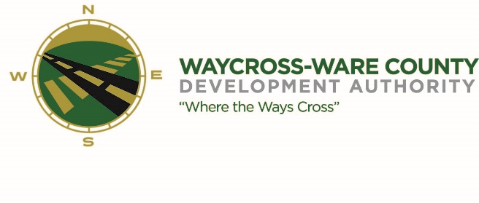
MEETING AGENDA
WWDA Board of Directors
April 20, 2023
10:00 A.M.
City Hall, Commissioners Chambers
Waycross, Ga 31503

Board Members Present: Staff Present:
Candice Moody-Rice Jason Rubenbauer
Dan Good Hillary Stringfellow
Rusty Hall
Michael-Angelo James Board Members Absent:
David Rafus James Willis
Daniel Morris (arrived at 11:25 AM)

- Call to Order
The regular meeting of the Waycross and Ware County Development Authority was called to order by Vice Chairman Candice Moody-Rice at 10:07 AM.

- Invocation/Pledge of Allegiance
Mayor Michael-Angelo James provided the invocation and led the Pledge of Allegiance.

- Approval of Agenda
Dan Good made a motion to approve the agenda as presented. Michael-Angelo James seconded the motion. All members present voted aye. Motion was unanimously approved by a vote of 5-0.

- Approval of Minutes
Michael-Angelo James made a motion to approve the minutes of the March 16, 2023, meeting as presented. Dan Good seconded the motion. All members present voted aye. Motion was unanimously approved by a vote of 5-0.

- Approval of Financials
- March Financials
Michael-Angelo James made a motion to approve the March Financials as presented. Dan Good seconded the motion. All members present voted aye. Motion was unanimously approved by a vote of 5-0.

- Community Reports
- Waycross-Ware County Chamber of Commerce
- Downtown Waycross Development Authority
- Waycross Convention & Visitors Bureau
- Coastal Pines Technical College
- South Ga. State College
- Ware County Board of Education

- Old Business
- Budget Discussion and request for action
- Discuss and request for action on the Use Agreement for Enviva access to Brown Drive.
- New Business
- Website discussion and request for action
- Board member nomination for the City of Waycross to replace Asod Brown discussion and request for action
- May meeting discussion and request for action
- Proposal to complete a drainage investigation and discussion and request for action

- Attorney’s Items
- Hillary Stringfellow – Gilbert, Harrell, Sumerford & Martin, P.C.

- President’s Report – Jason Rubenbauer

- Chairman’s Report – Daniel Morris

- Executive Session
- For discussion of land/lease and acquisition matters pursuant to 50-14-3(b)(1)(B)
- 50-14-3(b)(1)(B) and for discussion of personnel matters pursuant to 50-14-3(b)(2)
- Adjournment

