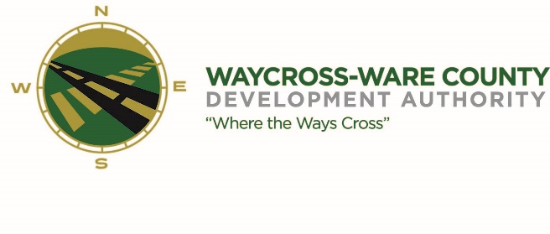
MEETING AGENDA
WWDA Board of Directors
April 20, 2023
10:00 A.M.
City Hall, Commissioners Chambers
Waycross, Ga 31503

Board Members Present: Staff Present:
Candice Moody-Rice Jason Rubenbauer
Dan Good Hillary Stringfellow
Rusty Hall
Michael-Angelo James Board Members Absent:
David Rafus James Willis
Daniel Morris (arrived at 11:38 AM)

- Call to Order
The regular meeting of the Waycross and Ware County Development Authority was called to order by Vice Chairman Candice Moody-Rice at 10:07 AM.

- Invocation/Pledge of Allegiance
Mayor Michael-Angelo James provided the invocation and led the Pledge of Allegiance.

- Approval of Agenda
Dan Good made a motion to approve the agenda as presented. Michael-Angelo James seconded the motion. All members present voted aye. Motion was unanimously approved by a vote of 5-0.

- Approval of Minutes
Michael-Angelo James made a motion to approve the minutes of the March 16, 2023, meeting as presented. Dan Good seconded the motion. All members present voted aye. Motion was unanimously approved by a vote of 5-0.

- Approval of Financials
- March Financials
Michael-Angelo James made a motion to approve the March Financials as presented. Dan Good seconded the motion. All members present voted aye. Motion was unanimously approved by a vote of 5-0.

- Community Reports
- Waycross-Ware County Chamber of Commerce
Executive Director, Paige Taylor mentioned that Business After Hours is to be held beginning at 5:00 PM at Coastal Candle Company. She also mentioned a Legislative Luncheon schedule at Memorial Satilla Health on May 23, 2023, beginning at 11:30 AM and lasting through 1:30 PM.

- Downtown Waycross Development Authority
Director Laura Dixon mentioned that there have bene three recent transactions for property acquisitions which has resulted in a new business coming to the downtown area.

- Waycross Convention & Visitors Bureau
Director Patrick Simmons noted an upcoming color run and a new app (Text My Gov) that is being implemented to allow residents the ability to more effectively communicate with city departments to report issues in their communities.

- Coastal Pines Technical College
Michael-Angelo James provided an update as an instructor for the college. He stated the end of the semester was quickly approaching.

- South Ga. State College
There were no representatives present, and no report was provided.

- Ware County Board of Education
Candice Moody-Rice provided and update on behalf of the system noting that all schools were preparing for required state testing.

- Old Business
- Budget Discussion and request for action
Jason Rubenbauer presented the proposed budget for 2023. After review of the proposal a motion was made by Michael-Angelo James to approve the budget as presented. Dan Good seconded the motion. All members present voted aye. Motion was unanimously approved by a vote of 5-0.
- Discuss and request for action on the Use Agreement for Enviva access to Brown Drive.
Michael-Angelo James made a motion to approve the Use Agreement for Enviva Biomass to access Brown Drive as presented. Rusty Hall seconded the motion. All members present voted aye. Motion was unanimously approved by a vote of 5-0.
- New Business
- Website discussion and request for action
Due to the absence of the Chairman, Daniel Morris, Michael-Angelo James made a motion to table any discussion or action on this matter until the next regular meeting. David Rafus seconded the motion. All members present voted aye. Motion was unanimously tabled by a vote of 5-0.

- Board member nomination for the City of Waycross to replace Asod Brown discussion and request for action
Dan Good made aa motion to submit the name of Stephen Burse to the City of Waycross to fill the unexpired term of Asod Brown. Rusty Hall seconded the motion. All members present voted aye. Motion was unanimously approved by a vote of 5-0.

- May meeting discussion and request for action
Jason Rubenbauer requested that the Board reschedule the regular meeting in May to be held on May 11, 20323 due to conflicts by the Chairman and Mr. Rubenbauer. Dan Good made a motion to approve the request as presented, Rusty Hall seconded the motion. All members present voted aye. Motion was unanimously approved by a vote of 5-0.

- Proposal to complete a drainage investigation and discussion and request for action
Michael-Angelo James made a motion to approve the drainage investigation as presented. David Rafus seconded the motion. All members present voted aye. Motion was unanimously approved by a vote of 5-0.

- Attorney’s Items
- Hillary Stringfellow – Gilbert, Harrell, Sumerford & Martin, P.C.

- President’s Report – Jason Rubenbauer

- Chairman’s Report – Daniel Morris

- Executive Session
- For discussion of land/lease and acquisition matters pursuant to 50-14-3(b)(1)(B)
- 50-14-3(b)(1)(B) and for discussion of personnel matters pursuant to 50-14-3(b)(2)
Michael-Angelo James made a motion to enter into Executive Session for the discussion of property and personnel matters. David Rafus seconded the motion. All members present voted aye. The Board entered into Executive Session following a unanimous vote at 10:57 AM.

During Executive Session, Chairman Daniel Morris arrived at 11:38 AM and assumed the responsibilities of the chair.

Candice Moody-Rice made a motion to exit Executive Session and re-enter Regular Session. Rusty Hall seconded the motion. All members voted aye. All members present voted aye. Regular session reconvened at 11:53 AM following a unanimous vote of 6-0.

- Adjournment
No additional business was conducted and the meeting was formally adjourned at 11:54 AM

