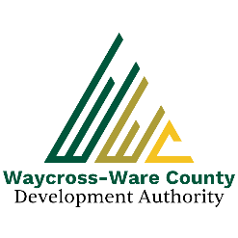

**REGULAR MEETING AGENDA**

**WWDA Board of Directors**

**December 4, 2024**

**9:00 A.M.**

**2855 Forest Drive**

**Waycross, Ga 31503**

1. **Call to Order**
2. **Invocation/Pledge of Allegiance**
3. **Approval of Agenda**
4. **Approval of Minutes**

* November 6, 2024

1. **Approval of Financial Reports**
   * October 31, 2024
2. **Community Reports**

* Waycross-Ware County Chamber of Commerce
* Downtown Waycross Development Authority
* Waycross Convention & Visitors Bureau
* Coastal Pines Technical College
* South Ga. State College
* Ware County Board of Education

1. **Old Business**

* Presentation of FY 2023 Audit

1. **New Business**

* Presentation, discussion, and request for action on the 2025 Meeting Schedule
* Presentation, discussion, and request for action on the 2025 Holiday Schedule
* Presentation, discussion, and request for action on the 2025 Budget Proposal
* Review, discuss, and readopt the Employee Handbook for FY 2025
* Review, discuss, and readopt the Fraud Prevention Policy and Awareness Policy for FY 2025

1. **Attorney’s Items**

* Hillary Stringfellow – Gilbert, Harrell, Sumerford & Martin, P.C.

1. **President’s Report – Jason Rubenbauer**
2. **Chairman’s Report – James Willis**
3. **Executive Session**

* For discussion of land/lease and acquisition matters pursuant to O.C.G.A. 50-14-3(b)(1)(B)

1. **Adjournment**