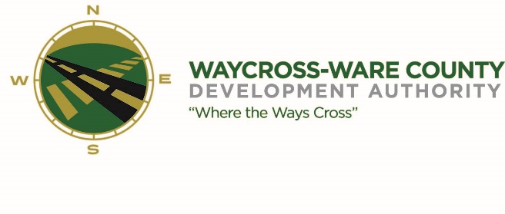
REGULAR MEETING AGENDA
WWDA Board of Directors
November 16, 2023
10:00 A.M.
City Hall, Commissioners Chambers
Waycross, Ga 31503

- Call to Order

- Invocation/Pledge of Allegiance

- Approval of Agenda

- Approval of Minutes

- Approval of Financials

- Community Reports
- Waycross-Ware County Chamber of Commerce
- Downtown Waycross Development Authority
- Waycross Convention & Visitors Bureau
- Coastal Pines Technical College
- South Ga. State College
- Ware County Board of Education

- Old Business

- New Business
- Discussion and request for action clean-up of 2821 & 2969 Industrial Blvd
- Discussion and request for action on Board of Directors Nomination
- Discussion and request for action on Board of Directors officers for FY2024
- Discussion and request for action on FY2024 Budget
- Discussion and request for action on Beaver Eradication from Parcel ID 050 03 002
- Discussion and request for action FY2024 WWDA Meeting Schedule
- Discussion and request for action to change December regular meeting date from December 21st to December 14th

- Attorney’s Items
- Hillary Stringfellow – Gilbert, Harrell, Sumerford & Martin, P.C.

- President’s Report – Jason Rubenbauer

- Chairman’s Report – Daniel Morris

- Executive Session
- For discussion of land/lease and acquisition matters pursuant to 50-14-3(b)(1)(B)
- Adjournment

