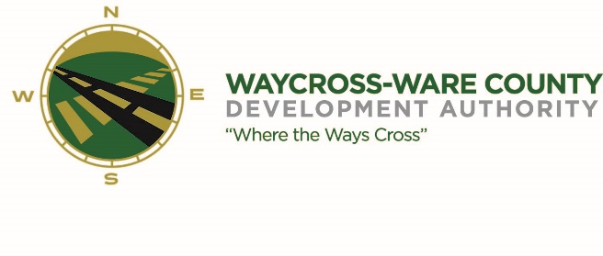
MEETING AGENDA
WWDA Board of Directors
October 12, 2023
10:00 A.M.
City Hall
Waycross, Ga 31503

Board Member Attendance: Staff Present:
Candice Moody-Rice- Present Jason Rubenbauer
Daniel Morris- absent Kalissa Corbitt
James Willis- present David Rafus- present
Dan Good- present
Rusty Hall- absent
Michael Angelo James- absent
Stephen Burse- present

Guest:
Hillary Stringfellow
Taylor Hereford
Pete Snell
- Call to Order
The regular meeting of the Waycross and Ware County Development Authority was called to order by Vice Chairman Candice Moody-Rice at 10:01 AM.

- Approval of Agenda
Dan Good made a motion to approve the agenda as presented. David Rafus seconded the motion. All members present voted aye. The motion was unanimously approved by a vote of 5-0.

- Approval of Minutes
- David Rafus made a motion to approve the minutes as presented. Seconded by Stephen Burse. All members voted aye. The motion was unanimously approved by a vote of 5-0.

- Approval of Financials
- No financial report

- Community Reports
- WWCOC- N/A
- DWDA- N/A
- WCVB- N/A
- CPTC- Pete Snell gave a brief update
- SGSC- Taylor Hereford gave a brief update.
- WCBOE- N/A

- Old Business
  - No old Business

- New Business
  - A motion was made by David Rafus to approve the 2022 Audit, seconded by James Willis. All members voted aye, unanimously approved 5-0.
  - After discussing the Fraud policy, a motion was made by Dan Good to approve it, seconded by David Rafus. All members voted aye. Unanimously approved 5-0.
  - A motion was made by Dan Good to approve the pass through disbursement for advertising from ware county to the Okfenokee gateway getaway.
- Attorney items
  - Hillary Stringfellow updated the board on current projects.

- Presidents Report

- Chairmans report

- Executive Session
- For discussion of land/lease and acquisition matters pursuant to 50-14-3(b)(1)(B)
- For discussion of personnel matters pursuant to 50-14-3(b)(2)
- David Rafus made a motion to enter executive session at 10:33 A.M.; seconded by Dan Good, unanimously approved 5-0
- Adjournment
- The WWDA Closed executive session at 11:05 A.M after a motion from James Willis and seconded by David Rafus. Unanimously approved 5-0.
- The meeting was adjourned at 11:06 A.M.

