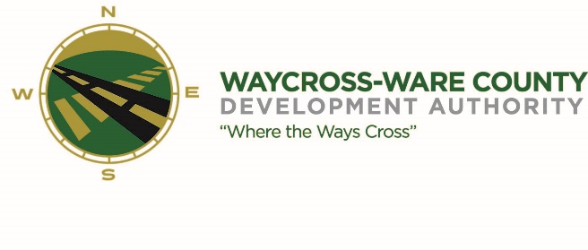
MEETING AGENDA
WWDA Board of Directors
August 17, 2023
10:00 A.M.
City Hall, Commissioners Chambers
Waycross, Ga 31503

- Call to Order

- Invocation/Pledge of Allegiance

- Approval of Agenda

- Approval of Minutes

- Approval of Financials

- Community Reports
- Waycross-Ware County Chamber of Commerce
- Downtown Waycross Development Authority
- Waycross Convention & Visitors Bureau
- Coastal Pines Technical College
- South Ga. State College
- Ware County Board of Education

- Old Business

- New Business
- Discussion and request for action on bids received pertaining to Water System Improvements in the Waycross-Ware County Business Park.

- Attorney’s Items
- Hillary Stringfellow – Gilbert, Harrell, Sumerford & Martin, P.C.

- President’s Report – Jason Rubenbauer

- Chairman’s Report – Daniel Morris

- Executive Session
- For discussion of land/lease and acquisition matters pursuant to 50-14-3(b)(1)(B)
- Adjournment

