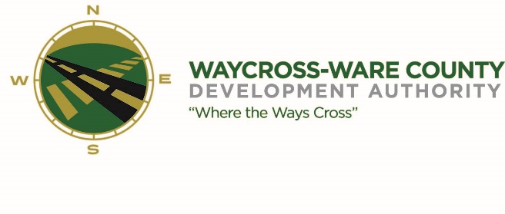
REGULAR MEETING MINUTES
WWDA Board of Directors
August 7, 2024
9:00 A.M.
2855 Forest Drive
Waycross, Ga 31503
Board members present: Board members present via telephone:
James Willis Michael Angelo-James
Rusty Hall Thomas Wesley
Stephen Burse
Dan Good

Guests present: Board members absent:
Hillary Stringfellow (via telephone) Candice Moody-Rice

Staff present:
Jason Rubenbauer
Chase McDonald

- Call to Order
The regular meeting of the Waycross Ware County Development Authority was called to order by chairman James Willis at 9:03.

- Invocation/Pledge of Allegiance
Stephen Burse provided the invocation and led the Pledge of Allegiance.

- Approval of Agenda
Rusty Hall made a motion to approve the agenda as presented. Dan Good seconded the motion. All present members voted aye, and the motion was passed 6-0.

- Approval of Minutes
- July 10, 2024
Michael Angelo-James made a motion to approve the minutes of the July 10th meeting as presented. Dan Good seconded the motion. All present members voted aye, and the motion was passed 6-0.
- Approval of Financial Reports
  - June 30, 2024
Jason Rubenbauer reported that income for the WWDA is as expected, but that there are some overhead costs that are slightly larger than initially budgeted for. Adjusting the budget for these costs will be an agenda item for the September meeting so that the board may make necessary amendments. Mr. Rubenbauer also noted that the Authority is awaiting payment from OneGeorgia and will apply for further funding once that payment is received.
- Community Reports
- Waycross-Ware County Chamber of Commerce
- Downtown Waycross Development Authority
- Waycross Convention & Visitors Bureau
- Coastal Pines Technical College
- South Ga. State College
- Ware County Board of Education
Patrick Simmons joined the meeting to give updates on the Okefenokee World Heritage Site bid, informing the board of two separate meetings that will be taking place on the 13th and the 22nd to discuss community support and concern for the bid. Mr. Simmons also informed the board of an app that will be launching soon for the city of Waycross called My Waycross, in which citizens will be able to report issues around the city, pay their utility bills, and more.

- Old Business
- Logo Proposal
Chase McDonald presented the logo initially proposed in the July 10th board meeting, after the board had more time to discuss and consider the logo redesign proposal. After short deliberation on the potential challenges of updating digital and physical marketing materials, the board decided to proceed with the rebranding effort. Rusty Hall made a motion to officially adopt the new logo. Stephen Burse seconded the motion. All present members voted aye, and the motion was passed 6-0.
- New Business
- Presentation, discussion, and request for possible action for a letter of support pertaining to the Okefenokee Wildlife Refuge World Heritage Site bid
Jason Rubenbauer presented materials relating to the Okefenokee World Heritage Site bid, including an email from Dr. William Clark requesting a letter of support from the WWDA. Mr. Rubenbauer asked the board if the Authority would take an official position on the matter, and the Authority’s attorney Hillary Stringfellow advised that the Authority makes no such commitment to either support -or refuse to support- the bid, until the city and county government takes an official stance. As the board is waiting for an official position from local government, there was no official action taken on this matter.

- Presentation, discussion, and request for action of board member nominations to the City of Waycross
Jason Rubenbauer presented a shortlist of potential candidates to replace Chris Kovacs on the board. The board agreed that the ideal candidate would be a business-minded individual in the healthcare industry. After a short discussion, the board agreed it would be best to wait for additional potential candidates to apply, so that the Authority can take advantage of the time remaining before it being necessary to replace the lost board member.
- Attorney’s Items
- Hillary Stringfellow – Gilbert, Harrell, Sumerford & Martin, P.C.
Hillary Stringfellow informed the board that she is still working on the ballfield title.
- President’s Report – Jason Rubenbauer
Jason Rubenbauer reported to the board that the Authority’s presence has been requested at multiple events in the coming months, including a South Georgia State College program and the Fairfield Hotel’s grand opening. Mr. Rubenbauer asked that the board let him know of their plans to attend by the end of the week.
- Chairman’s Report – James Willis
There was no report made available by Chairman James Willis.
- Executive Session
- For discussion of land/lease and acquisition matters pursuant to O.C.G.A. 50-14-3(b)(1)(B)
Stephen Burse motioned to enter executive session. Rusty Hall seconded the motion. The board entered executive session at 9:44 AM.

Dan Good made a motion to enter regular session once again. Stephen Burse seconded the motion. The board entered back into regular session at 10:57 AM.
- Adjournment
Dan Good motioned to adjourn the meeting. Stephen Burse seconded the motion. All present members voted aye, and the motion to adjourn the meeting was passed 6-0 at 10:59 AM.

