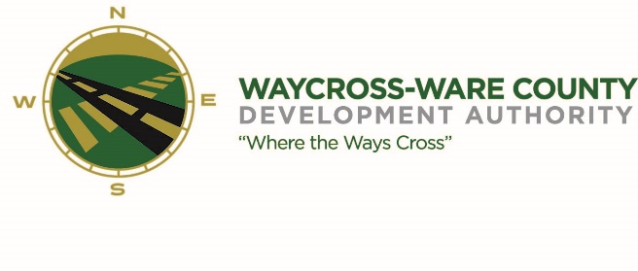
REGULAR MEETING AGENDA
WWDA Board of Directors
August 7, 2024
9:00 A.M.
2855 Forest Drive
Waycross, Ga 31503

- Call to Order

- Invocation/Pledge of Allegiance

- Approval of Agenda

- Approval of Minutes
- July 10, 2024

- Approval of Financial Reports
  - June 30, 2024

- Community Reports
- Waycross-Ware County Chamber of Commerce
- Downtown Waycross Development Authority
- Waycross Convention & Visitors Bureau
- Coastal Pines Technical College
- South Ga. State College
- Ware County Board of Education
- Old Business
- Logo Proposal

- New Business

- Presentation, discussion, and request for possible action for a letter of support pertaining to the Okefenokee Wildlife Refuge World Heritage Site bid

- Presentation, discussion, and request for action of board member nominations to the City of Waycross

- Attorney’s Items
- Hillary Stringfellow – Gilbert, Harrell, Sumerford & Martin, P.C.

- President’s Report – Jason Rubenbauer

- Chairman’s Report – James Willis

- Executive Session
- For discussion of land/lease and acquisition matters pursuant to O.C.G.A. 50-14-3(b)(1)(B)
- Adjournment

