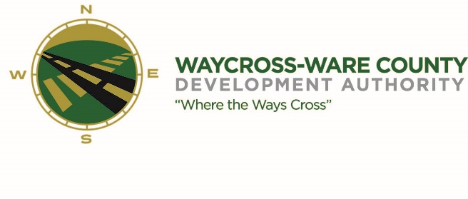
REGULAR MEETING AGENDA
WWDA Board of Directors
July 10, 2024
9:00 A.M.
2855 Forest Drive
Waycross, Ga 31503

- Call to Order

- Invocation/Pledge of Allegiance

- Approval of Agenda

- Approval of Minutes
- June 5, 2024
- Approval of Financial Reports
  - May 31, 2024
- Community Reports
- Waycross-Ware County Chamber of Commerce
- Downtown Waycross Development Authority
- Waycross Convention & Visitors Bureau
- Coastal Pines Technical College
- South Ga. State College
- Ware County Board of Education
- Old Business
- Logo Proposal
- New Business
- Presentation, discussion, and request for action of the listing of WWDA property on LoopNet
- Presentation, discussion, and request for action of Placer.ai platform
- Presentation, discussion, and request for action of Housing Plan information
- Presentation, discussion, and request for action of CPTC Foundation Golf Tournament request
- Presentation, discussion, and request for action of Okefenokee Swamp Run request
- Presentation, discussion, and request for action of Miss Pumpkin Fest Pageant request
- Presentation, discussion, and request for action of Chamber of Commerce Golf Tournament request
- Presentation, discussion, and request for action of Ware County property transfer request
- Attorney’s Items
- Hillary Stringfellow – Gilbert, Harrell, Sumerford & Martin, P.C.

- President’s Report – Jason Rubenbauer

- Chairman’s Report – James Willis

- Executive Session
- For discussion of land/lease and acquisition matters pursuant to O.C.G.A. 50-14-3(b)(1)(B)
- Adjournment

