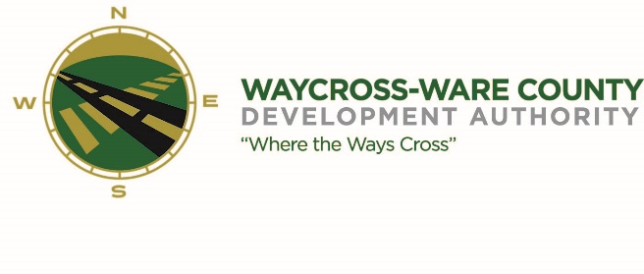
MEETING AGENDA
WWDA Board of Directors
June 22, 2023
10:00 A.M.
City Hall, Commissioners Chambers
Waycross, Ga 31503

- Call to Order

- Invocation/Pledge of Allegiance

- Approval of Agenda

- Approval of Minutes

- Community Reports
- Waycross-Ware County Chamber of Commerce
- Downtown Waycross Development Authority
- Waycross Convention & Visitors Bureau
- Coastal Pines Technical College
- South Ga. State College
- Ware County Board of Education

- Old Business
- Website discussion and request for action

- New Business
- Discussion and request for action on an Intergovernmental Agreement between Georgia’s Rural Center and the Waycross and Ware County Development Authority;
- Discussion and request for action pertaining to an advertising and promotion opportunity;
- Discussion and request for action to seek proposals to clean-up and repair the property located at 2821 Industrial Blvd;
- Discussion and request for action to seek proposals to clean the drainage ditch along the railroad track accessing GATX property
- Discussion and request for action to seek proposals to conduct a comprehensive drainage study due to the negative impacts of the industrial park during recent rain events causing flooding concern for numerous existing businesses and industries;
- Discussion and request for action to seek proposals for establishing and maintaining ground coverings at each of the new industrial park signs;

- Attorney’s Items
- Hillary Stringfellow – Gilbert, Harrell, Sumerford & Martin, P.C.
  - CF Rail
  - Simmons International

- President’s Report – Jason Rubenbauer

- Chairman’s Report – Daniel Morris

- Executive Session
- For discussion of land/lease and acquisition matters pursuant to 50-14-3(b)(1)(B)

- Adjournment

