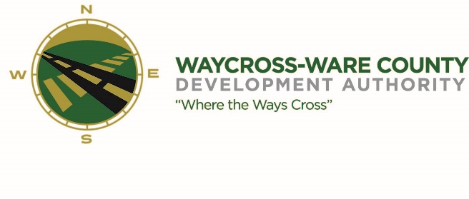
REGULAR MEETING AGENDA
WWDA Board of Directors
June 5, 2024
9:00 A.M.
2855 Forest Drive
Waycross, Ga 31503

- Call to Order

- Invocation/Pledge of Allegiance

- Approval of Agenda

- Approval of Minutes
- April 3, 2024

- Approval of Financial Reports
  - March 31, 2024
  - April 30, 2024

- Community Reports
- Waycross-Ware County Chamber of Commerce
- Downtown Waycross Development Authority
- Waycross Convention & Visitors Bureau
- Coastal Pines Technical College
- South Ga. State College
- Ware County Board of Education

- Old Business
- Presentation of USACE results on wetlands determination

- New Business
- Discussion and request for action on Logo Proposal
- Administrative Assistant Progress Report
- Discussion and request for action to participate in the WCHS Summer Internship Program

- Attorney’s Items
- Hillary Stringfellow – Gilbert, Harrell, Sumerford & Martin, P.C.

- President’s Report – Jason Rubenbauer

- Chairman’s Report – James Willis

- Executive Session
- For discussion of land/lease and acquisition matters pursuant to O.C.G.A. 50-14-3(b)(1)(B)
- Adjournment

