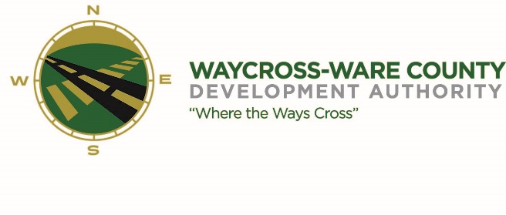
REGULAR MEETING MINUTES
WWDA Board of Directors
March 13, 2024
9:00 A.M.
2855 Forest Drive
Waycross, Ga 31503

Board Members Present: Staff Present:
James Willis Jason Rubenbauer
Candice Moody-Rice
Stephen Burse Rusty Hall Board Members Absent:
Thomas Wesley Dan Good
Chris Kovacs

Present via Telephone: Guests:
Mayor Michael-Angelo James Hillary Stringfellow

- Call to Order
The regular meeting of the Waycross and Ware County Development Authority was called to order by Chairman James Willis at 9:06 AM.

- Invocation/Pledge of Allegiance
Rusty Hall provided the invocation and led the Pledge of Allegiance.

- Approval of Agenda
Candice Moody-Rice made a motion to approve the agenda as presented. Rusty Hall seconded the motion. All members present voted aye. The motion was unanimously approved by a vote of 7-0.

- Approval of Minutes
Mayor Michael-Angelo James made a motion to approve the minutes of the February 7, 2024, meeting as presented. Candice Moody-Rice seconded the motion. All members present voted aye. The motion was unanimously approved by a vote of 7-0.

- Approval of Financials
There were no financials available for this meeting.

- Community Reports
Thomas Wesley provided an update on behalf of Coastal Pines Technical College. He reported that the college is moving into the new machine tool technology building on their Camden County Campus. He also stated that the Commercial Truck Driving program was being shortened from an eight-week course down to a five-week course. Finally, the college is looking at new programs to be offered and the College and Career Academy in Baxley.

No other community members were present to provide any updates.

- Old Business
There was no old business to discuss.

- New Business
- Discussion and request for action on a partnership with Valdosta State University and Retail Strategies authorizing payment not to exceed $2,500.00 if a grant by the USDA is awarded.
  - Jason Rubenbauer presented a proposal from Valdosta State University who is applying for a grant from the USDA to assist several communities, through a partnership with Retail Strategies, to create a plan for recruiting retail establishments to the region. This partnership will provide a report and could lead to the recruitment of specific retail establishments that would be a good fit for the Waycross and Ware County area. Following a brief discussion of the board, a motion was made by Stephen Burse to accept this proposal. The motion was seconded by Christpher Kovacs. All members present voted aye. The motion was unanimously approved by a vote of 7-0

- Presentation, discussion, and request for action to purchase the JobsEQ technology platform.
  - Jason Rubenbauer invited Wilson Cox with JobsEQ to give a brief presentation to the board on the abilities of the JobsEQ technology platform as a data tool for the organization. Following the presentation a motion was made by Stephen Burse to purchase the platform for one year at a cost not to exceed $8,625. Michael-Angelo James seconded the motion. Jason Rubenbauer mentioned working to get the local board of education and colleges to be partners to help absorb the costs. The board agreed to cover the first year even if we were not successful in getting the educational partners on board but would prefer to have them help offset the costs to the authority. All members present voted aye. The motion was unanimously approved by a vote of 7-0.

- Attorney items
Hillary Stringfellow brought the board up to date on the following items:
- The quiet title for the sliver of property recently purchase by GATX is nearing completion
- She is looking to find information on the Tsai family to obtain a quit claim deed for the ballfield property to clean-up the title issues that are still present
- She informed the board that Simmons has still not recorded the deed for the property which was released by the board under the company’s bankruptcy proceedings

- President’s report
No report was available.

- Chairman’s report

- Executive Session
Candice Moody-Rice made a motion to enter executive session for the purpose of discussing land/lease acquisition matters. Thomas Welsey seconded the motion. All members present votes aye. The motion to enter executive session was unanimously approved by a vote of 7-0.

At 10:25 A.M. the Board was in executive session.

Canidce Moody-Rice made a motion to re-enter the regular session. Rusty Hall seconded the motion. All members present voted aye. The motion to reenter the regular session was unanimously approved by a vote of 7-0.

Regular session was back open to the public at 10:40 A.M.

Adjournment
Michael-Angelo James made a motion to adjourn the regular meeting. Candice Moody-Rice seconded the motion. All members present voted aye. The meeting was adjourned at 10:45 AM

