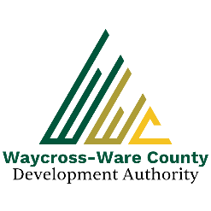

**REGULAR MEETING AGENDA**

**WWDA Board of Directors**

**February 12, 2025**

**9:00 A.M.**

**2855 Forest Drive**

**Waycross, Ga 31503**

* **Call to Order**
* **Invocation/Pledge of Allegiance**
* **Approval of Agenda**
* **Approval of Minutes**
* January 8, 2025
* **Approval of Financial Reports**
  + December 31, 2024
  + January 31, 2025
* **Community Reports**
* Waycross-Ware County Chamber of Commerce
* Downtown Waycross Development Authority
* Waycross Convention & Visitors Bureau
* Coastal Pines Technical College
* South Ga. State College
* Ware County Board of Education
* **Old Business**
* **New Business**
  + Discussion and request for nominations and action of Board member positions:
    - Chairman
    - Vice Chairman
    - Secretary
    - Treasurer
  + Presentation, discussion, and request for action for joint board retreat to include the city and county elected and appointed leadership to be provided by Hodge Consulting Services, LLC.
  + Presentation, discussion, and request for action on the 2025 Memorandum of Fees, Charges, and Procedure.
  + Presentation, discussion, and request for action to authorize the submission of the 2025 GTIB Grant Request
* **Attorney’s Items**
* Hillary Stringfellow – Gilbert, Harrell, Sumerford & Martin, P.C.
* **President’s Report – Jason Rubenbauer**
* **Chairman’s Report – James Willis**
* **Executive Session**
* For discussion of land/lease and acquisition matters pursuant to O.C.G.A. 50-14-3(b)(1)(B)
* **Adjournment**