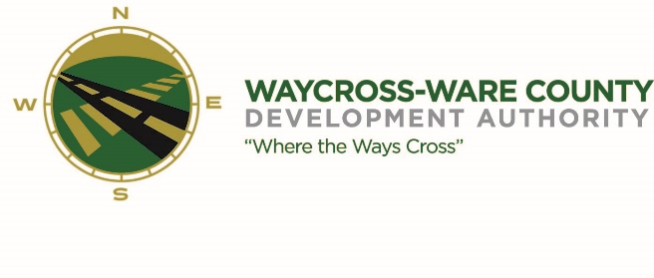
REGULAR MEETING AGENDA
WWDA Board of Directors
February 7, 2024
9:00 A.M.
2855 Forest Drive
Waycross, Ga 31503

- Call to Order

- Invocation/Pledge of Allegiance

- Approval of Agenda

- Approval of Minutes

- Approval of Financials

- Community Reports
- Waycross-Ware County Chamber of Commerce
- Downtown Waycross Development Authority
- Waycross Convention & Visitors Bureau
- Coastal Pines Technical College
- South Ga. State College
- Ware County Board of Education

- Old Business
  - Discussion of the Industrial Investment and Jobs Creation Incentive Matrix

- New Business
- Presentation and discussion on the Georgia Certified Economic Development Board Member training
- Presentation and discussion of the Transaction Application
- Presentation and discussion of the 2024 schedule of fees and charges
- Presentation and discussion of adverting, promotion, marketing, and other items to bring awareness to Waycross and Ware County
- Discussion and request for action for REBA bank account
- Discussion and request for action to change the March meeting from March 6th to March 13th at 9:00 am

- Attorney’s Items
- Hillary Stringfellow – Gilbert, Harrell, Sumerford & Martin, P.C.

- President’s Report – Jason Rubenbauer

- Chairman’s Report – James Willis

- Executive Session
- For discussion of land/lease and acquisition matters pursuant to O.C.G.A. 50-14-3(b)(1)(B)
- Adjournment

