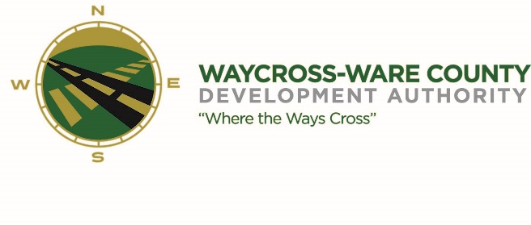
REGULAR MEETING MINUTES
WWDA Board of Directors
January 3, 2024
9:00 A.M.
City Hall
Waycross, Ga 31503

Board Members Present: Staff Present:
James Willis Jason Rubenbauer
Candice Moody-Rice
Stephen Burse Rusty Hall Board Members Absent:
Dan Good
Thomas Wesley
Chris Kovacs Guests:
Mayor Michael-Angelo James Hillary Stringfellow
Tom Woodward
Barbara Miller
- Call to Order
The regular meeting of the Waycross and Ware County Development Authority was called to order by Chairman James Willis at 9:06 AM.

- Invocation/Pledge of Allegiance
Mayor Michael-Angelo James provided the invocation and led the Pledge of Allegiance.

- Approval of Agenda
Mayor Michael-Angelo James made a motion to approve the agenda as presented. Dan Good seconded the motion. All members present voted aye. The motion was unanimously approved by a vote of 8-0.

- Approval of Minutes
Mayor Michael-Angelo James made a motion to approve the minutes of the November 29, 2023, meeting as presented. Rusty Hall seconded the motion. All members present voted aye. The motion was unanimously approved by a vote of 8-0.

- Approval of Financials
Dan Good made a motion to approve the November 2023 financials as presented. Candice Moody-Rice seconded the motion. All members present voted aye. The motion was unanimously approved by a vote of 8-0.

- Community Reports
No community partners were present to provide any updated information.

- Old Business
There was no old business to discuss.

- New Business
- Discussion and request for action on sponsorship of the Legislative Meet and Greet
  - Mayor Michael-Angelo James made a motion to approve the recommendation by the President/CEO to sponsor the Legislative Meet and Greet in partnership with the Douglas-Coffee County Chamber and Development Authority and the Irwin County Development Authority in an amount not to exceed $1200. Candice Moody-Rice seconded the motion. All members present voted aye. The motion was unanimously approved by a vote of 8-0.

- Discussion and request for action on the proposed WWDA Employee Handbook Updates
  - Mayor Michael-Angelo James made a motion to adopt the Employee Handbook as presented. Stephen Burse seconded the motion. All members present voted aye. The motion was unanimously approved by a vote of 8-0.

- Discussion and request for action on the Incentive Matrix
  - James Willis under the recommendation of the Authority’s legal counsel asked to move this to the February meeting to allow for additional time to review by the new board members.

- Attorney items
Hillary Stringfellow stated that she brought the Board up to date on Project Blackwater who has made their first draw. She also mentioned that GATX legal counsel and she has spoken and are working to clear up information on the lease agreements on the recent property transactions. She hopes this will be finalized in the coming months.

- President’s report
Jason Rubenbauer presented a verbal report of the reorganization of the office due to a staff change and has also been working on finalizing the Employee Handbook.

- Chairman’s report
James Willis had no report as it was the first meeting of the year and the first meeting of his Chairmanship.

- Executive Session
Mayor Michael-Angelo James made a motion to enter executive session for the purpose of discussing land/lease acquisition matters. Candice Moody-Rice seconded the motion. All members present votes aye. The motion to enter executive session was unanimously approved by a vote of 8-0.

At 9:33 A.M. the Board was in executive session.

Mayor Michael-Angelo James made a motion to re-enter the regular session. Candice Moody-Rice seconded the motion. All members present voted aye. The motion to reenter the regular session was unanimously approved by a vote of 8-0.

Regular session was back open to the public at 11:09 A.M.

Adjournment
No additional business was conducted, and the meeting was formally adjourned at 11:12 AM

