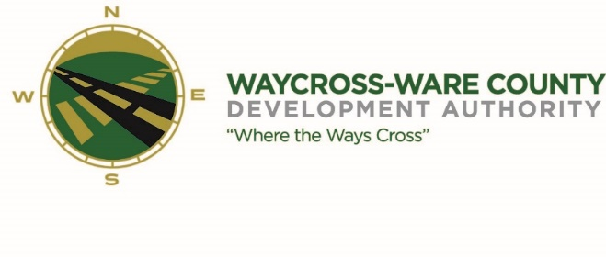
July 19, 2018
10:00 A.M.
MEETING AGENDA
WWDA Board of Directors

- Call to Order
- Invocation
- Approval of Agenda
- Approval of June 21, 2018 Minutes
- Chairman’s Report:
- Report of Activities
  - August Meeting
- Executive Director’s Report:
- Report of Activities
- Finance Committee:
- Report of Finances
- SPLOST Balances:
  - 2008 Balance: $908,031.68
  - 2014 Balance: $549,091.01 (reflects the Norton Property payment)
- Pending Business:
- Chamber of Commerce/Business Community Report
- Downtown Waycross Development Authority Report
- Main Street Report
- Tourism
- Update: NextSite-Charles Branch
- New Business:
- Accounting Policy
- PILOT payment
- Manufacturing Day, October 5, 2018
- Workforce Committee July 24, 2018
- State of the Port Luncheon September 20, 2018
- Attorney’s Items
- none
- Executive Session:
- For discussion of land lease and acquisition pursuant to 50-14-3(b)(1)(B)
- Adjournment

