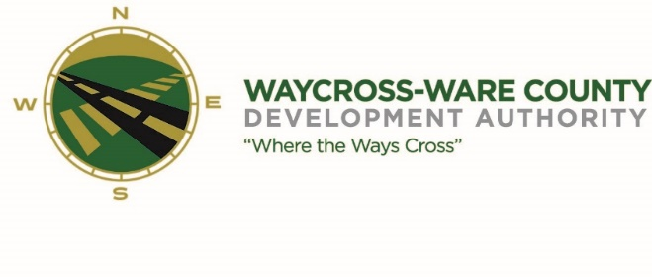
February 15, 2018
10:00 A.M.
MEETING AGENDA
WWDA Board of Directors

- Call to Order
- Invocation
- Approval of Agenda
- Approval of January 18, 2017 Minutes
- Chairman’s Report:
- Report of Activities
- Executive Director’s Report:
- Report of Activities
- Finance Committee:
- Report of Finances
  - Accounting Contract
  - Budget
  - Audit Update
- Pending Business:
- Chamber of Commerce/Business Community Report
- Downtown Development Authority Report
- Main Street Report
- Tourism
- Coastal Plains Coalition
- New Business:
- Georgia Power Easement
- Executive Session:
- For discussion of land lease and acquisition pursuant to 50-14-3(b)(1)(B)
- For discussion of personnel matters pursuant to 50-14-3 (b) (2)
- Adjournment

